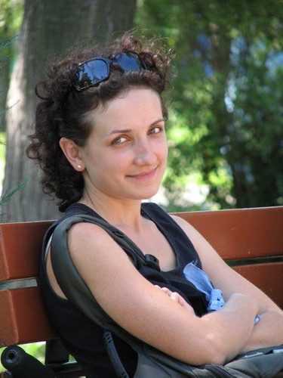
Which Plate Boundary?

“My name is Catherine and I live in San Francisco, United States.
We get earthquakes here a lot. Some of them are really small, and some of them are fairly big.
People say that one day there’s going to be a really big one that will cause a lot of destruction.
Thankfully, we don’t get any volcanoes.”

Complete the following sentences by selecting the correct words:
Catherine lives in San Francisco / Iceland / Australia, which is on a convergent / divergent / conservative plate boundary.
The plates here move apart / move together / slide past each other.

In the box below, draw a sketch to show what happens at the plate boundary where Catherine lives. Add labels to explain what’s happening in your sketch.

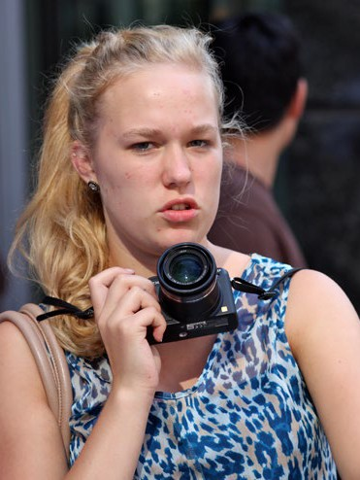

“My name is Ruby. I live in Reykjavik, Iceland.
We have lots of volcanoes here in Iceland. They don’t do much damage and sometimes you can go to look at them.
If a volcano erupts, an ash cloud can mean planes are unable to fly into the airport here.
We get earthquakes here as well, but they’re usually small ones. Sometimes you can’t even feel them.”

Complete the following sentences by selecting the correct words:
Ruby lives in Ireland / Iceland / England, which is on a convergent / divergent / conservative plate boundary. The plates here move apart / move together / slide past each other.

In the box below, draw a sketch to show what happens at the plate boundary where Ruby lives. Add labels to explain what’s happening in your sketch.



“Hey! I’m Fernando and I live in L’Aquilla, Italy.
We had a really bad earthquake here back in 2009. It destroyed my house and I was lucky to get out alive. Earthquakes don’t happen all the time in Italy, but when they do occur it can cause damage. Over 300 people died and 1500 were injured.
In other parts of Italy, there are large volcanoes. One of them is Mount Etna which erupts fairly often. You may have heard of Vesuvius, as well. That was the volcano that destroyed the Roman city of Pompeii.
We don’t have earthquakes and volcanoes every day, though. Most times it’s just normal. But when they happen, they can lead to destruction."

Complete the following sentences by selecting the correct words:
Fernando lives in Italy / Iceland / United States, which is on a convergent / divergent / conservative plate boundary.
The plates here move apart / move together / slide past each other.

In the box below, draw a sketch to show what happens at the plate boundary where Fernando lives. Include as much detail as you can in the sketch. Add labels and annotations to explain the processes taking place.

